**Frenchtown Presbyterian Church**

PO Box 114, 22 Fourth St. Frenchtown, NJ 08825

908-996-2227

Website: www.frenchtownpres.org

Pastor Cell - 609-303-0500

**Worship 9:30AM**

**Clerk of Session**

Kathy Skerbetz – 908-720-6533

**Session (Elders)**

Maureen Breiner Bill Penyak

Shari Bethman Bjellquist Paul Pfisterer

Jennifer Campbell Tonya Reese

Gayla Gerhardt Carl Stokes

John Fiebig Kathy Skerbetz

**Board of Deacons**

Carole Barrett Barbara Kerekes

Sharon Beck Lorraine Sellitto

Debbie Godown Eileen Warkala

Ken Gerhardt Amy Verecha

**Pastor**

Rev. Dr. Merideth Mueller-Bolton

pastormerideth@gmail.com

**Church Secretary**

Lea Raymond

office@frenchtownpres.org

**Financial Manager**

Mary Ann Hampton

finance@frenchtownpres.org

**Music Director**

Hugh Sung

hughsung@gmail.com



**FRENCHTOWN PRESBYTERIAN CHURCH**

**November 26, 2023**

**Welcome to all who worship with us this morning!**

Prelude

Welcome & Announcements

**God Gathers Us in Love**

Call to Worship (from Psalm 100)

Leader: Lord, you have been our dwelling place;

**People: We come today to rest in you.**

Leader You have been the voice that guides us;

**People:** **We come today to listen.**

Leader: You have been the host who feeds us;

**People:** **We come today to be filled.**

Leader: You have been our joy and crown;

**People: We come today to sing your praise!**

*Hymn #716 “God Whose Giving Knows No Ending”

Prayer of Adoration

Call to Confession

Prayer of Confession

**Merciful God, we confess that once again, we have done what is evil in your sight. We have hurt people by action and inaction. We have wounded creation, by action and inaction. We have chosen our ways over yours, by action and inaction. Turn us towards goodness, Lord. Forgive our past and shape our future that we might build your kingdom here. In the strong name of Christ, we pray. Amen.**

Assurance of Forgiveness

*Passing of the Peace

Gloria Patri#582 “Glory to God, Whose Goodness Shines on Me”

Minute for Mission – Tonya Reese

**God Speaks to Us Through God’s Word**

Scripture Reading Psalm 50:1-14, 23

*Hymn #399 Refrain: God welcomes all,*

*strangers and friends;*

*God's love is strong*

*and it never ends.*

Scripture Reading Matthew 28:16-20

Sermon “The E Word”

**God Calls Us to Respond**

*Hymn #694 “Great God of Every Blessing”

Invitation to the Offering

Please consider donating online using our QR code (aim your phone’s camera here, then click on the link that appears):



Offertory

Doxology #606 “Praise God from Whom All Blessings Flow”

Prayer of Dedication

Affirmation of Faith (unison) (from Phil. 2:5–11)

**Christ Jesus, though he was in the form of God, did not regard equality with God as something to be exploited, but emptied himself, taking the form of a slave, being born in human likeness. And being found in human form he humbled himself and became obedient to the point of death — even death on a cross. Therefore, God also highly exalted him and gave him the name that is above every name, so that at the name of Jesus every knee should bend, in heaven and on earth and under the earth, and every tongue should confess to the glory of God: Jesus Christ is Lord! Amen.**

Prayers of the People and The Lord’s Prayer

**God Sends Us Out to Reflect God’s Love**

*Hymn #703 “Jesus Thy Boundless Love to Me”

*During the singing of the hymn as an offering of thanks and commitment, you are invited to come forward and place your pledge in the basket on the steps in the front of the church.*

Charge and Blessing

Benediction

Benediction Response #750 “Goodness is Stronger than Evil”

Postlude

**\*\*\*\*\*\*\*\*\*\*\*\*\*\*\*\*\*\*\*\*\*\*\*\*\*\*\*\*\*\*\*\*\*\*\***

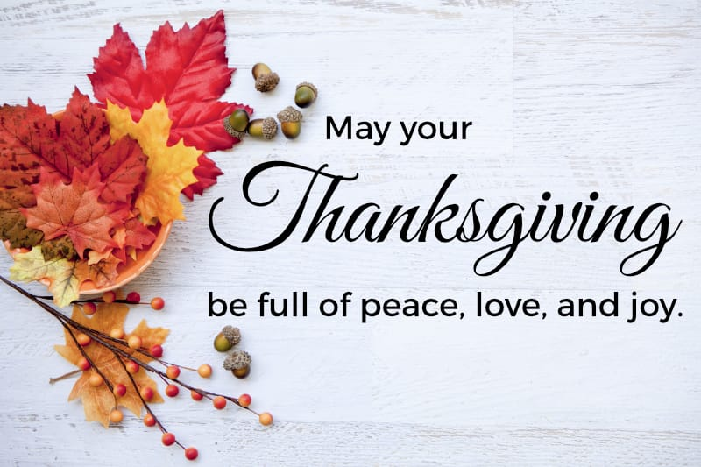

**MISSION STATEMENT**

We are a body of believers in Jesus Christ the Lord that strives to be a living reflection of God’s love. We come together to confirm our individual faith while spreading the message of hope and love by serving those in need through mission and outreach.

**NEWS AND EVENTS**

**EVENTS DURING THE WEEK** –**Nov. 27-December 3**

**Monday**

Decorating the Church for Advent, 9:30am

**Tuesday**

AA Meeting 6:30am

Card Games, 1-4pm in Fellowship Hall

AA Meeting, 8pm

**Wednesday**

AA Meeting 7:30pm

**Thursday**

AA Meeting 6:30am

**Friday**

Alanon Meeting 12-1pm

**Saturday**

Saturday Women's AA Group Meeting 9am

AA Meeting 7pm

**Next Sunday**

Food Pantry Sunday

**Decorating the sanctuary**

In preparation for the Season of Advent, we will be decorating and hanging the greens in the Sanctuary on Monday November 27th at 9:30am.  Any help would be appreciated.  Thank you!



**Parents Night out at FPC**

Enjoy and night out on us. Saturday December 9th from 6-8:30pm

There will be crafts, movies, games, snack, pizza and….  
Santa. Please RSVP by Dec. 6 to Jen at 908-502-2575.

**Church Directory**

The new Church Directory is online and available!  Go to <https://members.instantchurchdirectory.com/>

and follow the instructions to login for the first time.

**Poinsettia Orders**

Now taking orders for Poinsettias. Flowers are $8.50 Red or White. Orders are due by December 10th. Order forms are available at the back of the church.

**Christmas Cantata**

Join Sunday December 10th at 2pm for a musical celebration of the Christmas story by Lloyd Larson, “A New and Glorious Morn!.” This is a fun cantata that tells the Christmas story through music featuring favorite carols and some original music. Help with donations of finger food snacks for after the Cantata would be

appreciated!  Thank you!

**Food Pantry Sunday**

Next Sunday, the first Sunday of the month, has been designated as Food Pantry Sunday. If you able, we would appreciate anything you can bring. Check the weekly email for requested items. Thank you for your continued support.